**Verification and Validation:**

This part of the project aims to verify and validate the simulated model to the selected real world road network. Purpose of verification is to make sure that the representing model reflects observed system whereas goal of the validation is to represent a model with good behavior closely related to the observed system for decision-making purposes. In general validation seems similar to verification but we have to recognize that the validation evaluates the representing model using real data. The process of verifying and validating is often very costly and conservative to conclude that a model is valid over the intended application. So, the tests are conducted till the approximate confidence is obtained to validate the model.

Verification process is conducted on the modeled road network, the model results are compared with the conceptual model of the real road network. The concepts compared in the system involve total number of road connections, road network formation, directions of the roads, elements involved in the network (Stop lines, Speed limits, Pedestrians path, etc). Verification of model can be achieved by several methods, e.g.:

* Make a flow-diagram which includes the possible actions.
* Checking the correctness of the model multiple times.
* Examining the model outputs with different input parameters for accurateness.
* To have some experts to check the model.

In the process of validation one has to compare the systems with the various measures of performances (MOP’s). Measured performances of the project include flow of the vehicles, queue length, traffic signal timing, delay and so forth. Validation process has several methods to approach; good validation can be achieved by maximum number of approaches to be fulfilled. Some of them are given by:

* Building a model which reassembles the real field model.
* Usage of proper techniques for comparing output of the built model with the data collected in the real field model.
* Examining the correctness of inputs.
* Input-output transformations.
* Series of sample tests on the model.
* Developing a model with high face validity.

**Verification of simulation model:**

The representing model of our experiment is developed in view of the conceptual model. In a simulation project it is often to make mistakes like inaccurate measurements/assumptions. So as to check the mistakes, verification is done to the simulation model with respect to conceptual model. The following figure represents the conceptual model and simulation model of the road network.

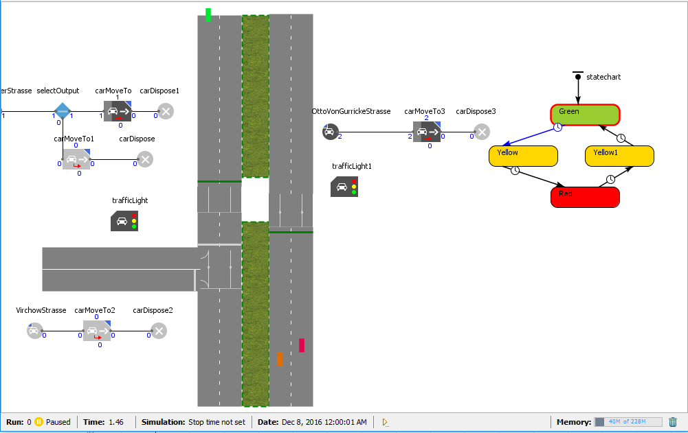

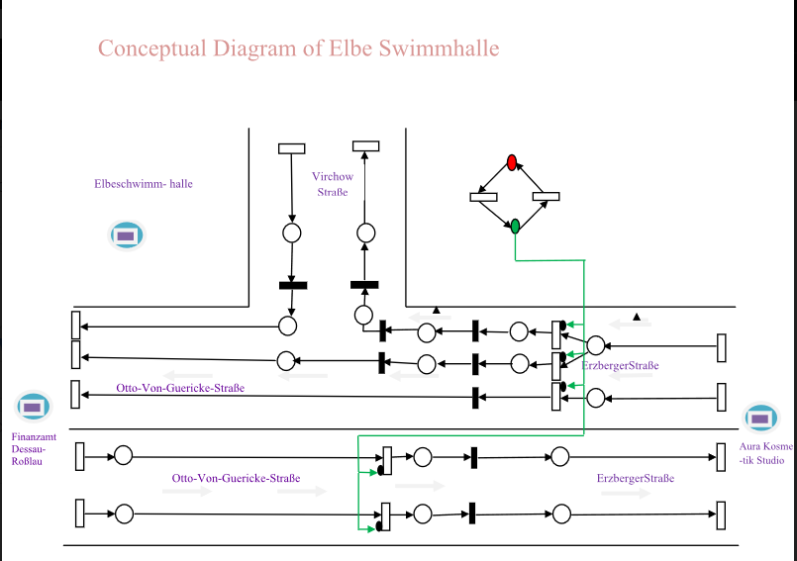

Fig1: Comparison of conceptual and simulated model.

By comparing above models we can learn the following concepts which approximate the models to be verified:

* There are three 2-lane road lines. They are:
  + One-way two lane road lines towards Erzberger Strasse from Otto-Von-Guericke Strasse.
  + One-way two lane road lines from Erzberger Strasse to Otto-Von-Gurricke Strasse.
  + Two-way two lane road lines from/to Virchow Strasse connected to road line which runs from Erzberger Strasse to Otto-Von-Gurricke Strasse.
* There are two traffic lights each on the one-way road lines.
* Both the one-way lines are divided by dual carriage way.

**Validation for the simulation model:**

The real field data is collected and the required calculations are made on the data collected. The calculated data is given as input for the simulation model. There is a chance of committing calculations/programming errors. So as to rectify the errors validation is done on the simulation model. We have considered the following factors to validate the model.

* In flow of the vehicles.
* Signal timings (i.e. both the signals are synchronized to each other).
* Average queue length.

In flow of the vehicles is calculated by considering the real field data. The data is analyzed and observed to be in a log-normal distribution with the respective values. Therefore observed distribution is given to the model to get the analyzed output from the simulated model. Secondly synchronization of signal timings is clarified from the output. Furthermore the queue lengths are compared with the input-output transformations. Queue lengths of the models are verified by the confidence interval graphs. Overall, the model is said to be valid by comparing the historical input data with the simulation model outputs. The following figures show confidence interval graphs, configuration of the lognormal distribution and output of the model.

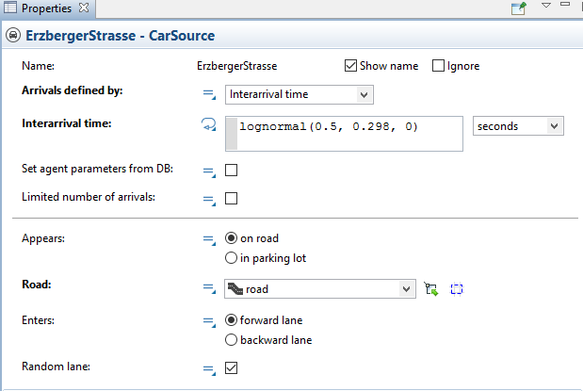

Fig2: Optimization of input parameters.

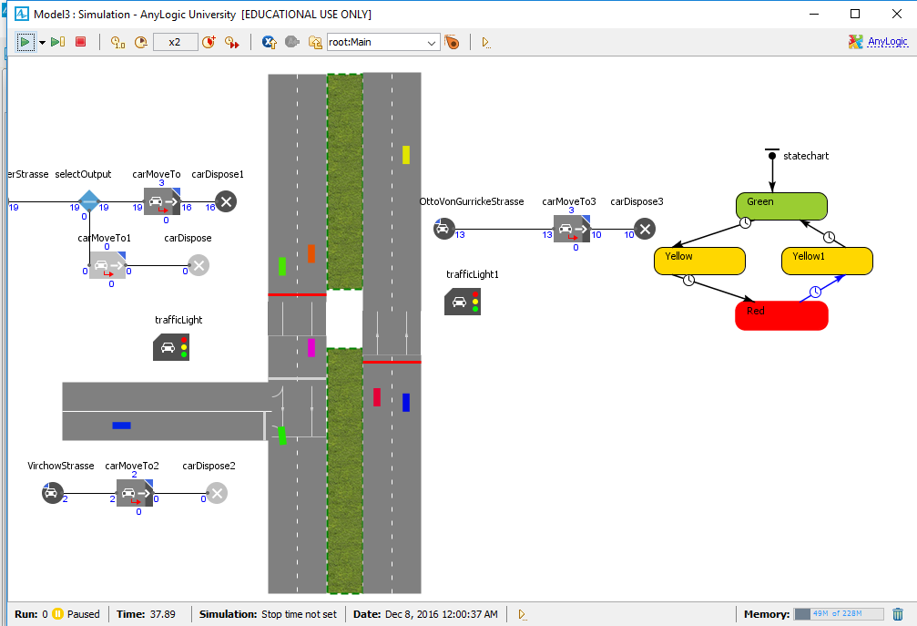

Fig3: Output of the model with synchronized signals.

Fig4: confidence interval graphs.

**Problems faced and rectified:**

* Programming to find the queue length from the model.
* Good output was not found due to improper configuration of road length.

**Learned from project:**

* The data must be collected in consideration with the requirements of the project.
* We should be careful while checking the correctness of the simulation, errors found, conceptual model and implementation.
* Appropriate and valuable techniques must be selected for the proper validation.
* Very difficult to validate a model to be ideal/perfect. We can only approximate the model.

**References:**

* Sargent, Robert G. "Verification and validation of simulation models." *Proceedings of the 37th conference on Winter simulation*. winter simulation conference, 2005.
* Pursula, Matti. "Simulation of traffic systems-an overview." *Journal of Geographic Information and Decision Analysis* 3.1 (1999): 1-8.
* Horiguchi, Ryota, and Masao Kuwahara. "Verification process and its application to network traffic simulation models." *Journal of advanced transportation* 36.3 (2002): 243-264.
* Rakha, Hesham, et al. "Systematic verification, validation and calibration of traffic simulation models." *75th Annual Meeting of the Transportation Research Board, Washington, DC*. 1996.
* Ni, Daiheng, et al. "Systematic approach for validating traffic simulation models." *Transportation Research Record: Journal of the Transportation Research Board* 1876 (2004): 20-31.